Jose Berlingeri, jberlingeri3, Section A

Victor Rohlfs, vrohlfs3, Section A

Rohith Ravi, rravi6, Section A

Brian Cai, bcai7, Section A

CS 4400

GROUP 37

Phase 2

EER Diagram:

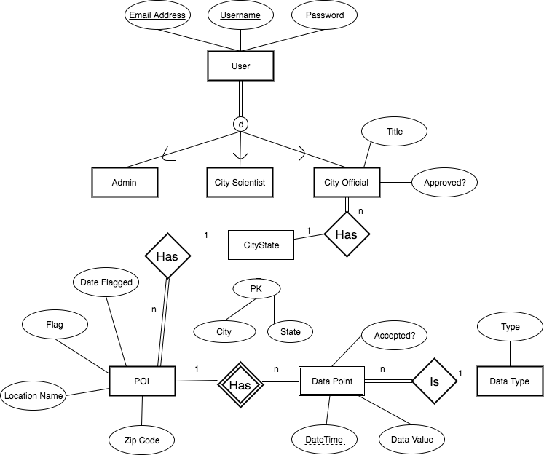

Relational Schema Diagram:

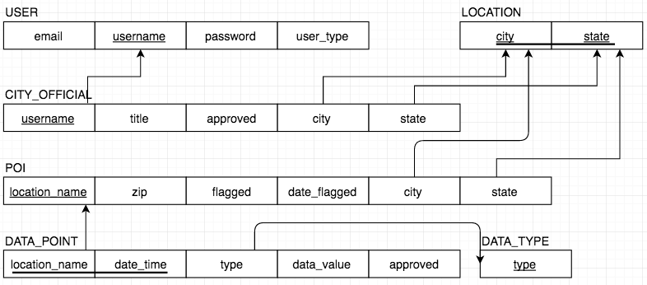

SQL Statements:

**CREATE TABLE** `cs4400_37`.`LOCATION`

(`city` VARCHAR( 100 ) **NOT NULL** ,

`state` CHAR( 2 ) **NOT NULL** ,

**CONSTRAINT** PK_LOCATION **PRIMARY KEY** (`city`,`state`));

**CREATE TABLE** `cs4400_37`.`DATA_TYPE`

(`type` VARCHAR( 100 ) **NOT NULL** ,

**PRIMARY KEY** (`type`));

**CREATE TABLE** `cs4400_37`.`USER`

(`email` VARCHAR( 100 ) **NOT NULL** ,

`username` VARCHAR( 100 ) **NOT NULL** ,

`password` VARCHAR( 100 ) **NOT NULL** ,

`user_type` ENUM( 'admin', 'city_scientist', 'city_official' ) **NOT NULL** ,

**PRIMARY KEY** ( `username` ),

**UNIQUE** ( `email` ));

**CREATE TABLE** `cs4400_37`.`CITY_OFFICIAL`

(`username` VARCHAR( 100 ) **NOT NULL** ,

`title` VARCHAR( 100 ) **NOT NULL** ,

`approved` BOOL **NOT NULL** **DEFAULT** 0,

`city` VARCHAR( 100 ) **NOT NULL** ,

`state` CHAR( 2 ) **NOT NULL** ,

**PRIMARY KEY** ( `username` ),

**FOREIGN KEY** (`username`) **REFERENCES** `USER` (`username`)

**ON DELETE** CASCADE **ON UPDATE** CASCADE,

**FOREIGN KEY** (`city`, `state`) **REFERENCES** `LOCATION` (`city`, `state`)

**ON DELETE** CASCADE **ON UPDATE** CASCADE);

**CREATE TABLE** `cs4400_37`.`POI`

(`location_name` VARCHAR( 100 ) **NOT NULL** ,

`zip` CHAR( 5 ) **NOT NULL** ,

`flagged` BOOL **NOT NULL** **DEFAULT** 0,

`date_flagged` DATE **DEFAULT** NULL,

`city` VARCHAR( 100 ) **NOT NULL** ,

`state` CHAR( 2 ) **NOT NULL** ,

**PRIMARY KEY** ( `location_name` ),

**FOREIGN KEY** (`city`, `state`) **REFERENCES** `LOCATION` (`city`, `state`)

**ON DELETE** CASCADE **ON UPDATE** CASCADE);

**CREATE TABLE** `cs4400_37`.`DATA_POINT`

(`location_name` VARCHAR( 100 ) **NOT NULL** ,

`date_time` TIMESTAMP **NOT NULL** ,

`type` VARCHAR(100) **NOT NULL** ,

`data_value` INTEGER **NOT NULL**,

`approved` BOOL **NOT NULL** **DEFAULT** 0,

**CONSTRAINT** PK_DATA_POINT **PRIMARY KEY** ( `location_name`, `date_time` ),

**FOREIGN KEY** (`location_name`) **REFERENCES** `POI` (`location_name`)

**ON DELETE** CASCADE **ON UPDATE** CASCADE,

**FOREIGN KEY** (`type`) **REFERENCES** `DATA_TYPE` (`type`)

**ON DELETE** CASCADE **ON UPDATE** CASCADE);

SQL Assumptions:

* City Official attribute **Approved** is a Boolean attribute set to **DEFAULT** as FALSE (i.e. “pending”). The value TRUE would mean the City Official is “approved”. If the City Official is ever denied registration or fired, then we assume that it will be deleted from the database.
* In the application, any **State** attribute will follow the abbreviated state name format “XX” (i.e. “GA”, “FL”). For that reason we defined the domain **CONSTRAINT** as Char(2).